Q1. In the following statement ________
- Relation is a special case o function
- Function is special case of relation
- Both relation & function are same

- (iii) is true, (i) &(ii) are false
- (i) is true, (ii) & (iii) are false
- (ii) is true, (i) & (iii) are false
- All (i), (ii) & (iii) are true
Q2. If $\cos\left(θ_{1}\right)+\cos\left(θ_{2}\right)$+$\cos\left(θ_{3}\right)+\cos\left(θ_{4}\right)=-4,$then find the value of $\cot\left(\frac{θ_{1}}{2}\right)+\cot\left(\frac{θ_{2}}{2}\right)+\cot\left(\frac{θ_{3}}{2}\right)+\cot\left(\frac{θ_{4}}{2}\right)=$
- 4
- 1
- 2
- 0
Q3. The tangent to the curve y=e^{2x} at the point (0,1) meets the x-axis at _________
- (2,0)
- (0,0)
- ($-\frac{1}{2},0)$
- ($\frac{1}{2},0)$
Q4. Which of the following is not a root of $f\left(x\right)=x^{3}-11x^{2}+36x-36?$
- 2
- 4
- 3
- 6
Q5. Let u and v be two vectors. Then |u-v|=||u|-|v|| if and only if
- |u|=|v|
- u and v have the opposite direction
- u and v have the same direction
- u and v are perpendicular to each other
Q6. $\int_{0}^{\frac{π}{2}}{\frac{x+sinx}{1+cosx} dx}$=
- $\frac{π}{4}$
- $\frac{π}{3}$
- $\frac{π}{2}$
- $\frac{π}{6}$
Q7.the directrix of the parabola$2y^{2}+25x=0 is$_________
- $8x-25=0$
- $8y-25=0$
- $25x-28=0$
- $25x-8=0$
Q8. If $\frac{x^{2}+5x+7}{{\left(x-3\right)}^{3}}=\frac{A}{(x-3)}+\frac{B}{{\left(x-3\right)}^{2}}+\frac{C}{{\left(x-3\right)}^{3}}$ then 9A-3B+C=
- 2
- 5
- 7
- 9
Q9. $\int{\frac{3^{x}}{\sqrt{1-9^{x}}} dx=}$
- $\sin^{-1}{{(3}^{x}).{\left(log3\right)}^{-1}+c}$
- -$\sin^{-1}\left(3^{x}\right).log3+c$
- $\frac{1}{3}\sin^{-1}\left(3^{x}\right)+c$
- $\frac{1}{9}\sin^{-1}\left(3^{x}\right)+c$

Q10. The point to which the origin should be shifted to that the equation $y^{2}-6y-4y+13=0$ will not contain term in y and the constant term, is _________
- (1,1)
- (1,2)
- (2,1)
- (1,3)
Q11. If on an average 9 mountain climbers out of 10 return safely, what is the probability that with 5 climbers out, at least 4 will return safely?
- $\frac{9^{5} x 7}{50000}$
- $\frac{9^{4} x 7}{50000}$
- $\frac{9^{5} }{100000}$
- $\frac{9^{3} x 3}{50000}$
Q12. If S₁ and S₂ are two straight lines such that the reflection of S₁ and the reflection of S₂ in S₁ coincide, the angle between S₁ and S₂ is equal to
- $\frac{π}{3}$
- $\frac{π}{6}$
- $\frac{π}{4}$
- Data insufficient
Q13. The equation of the asymptotes of the hyperbola $2x^{2}+5xy+2y^{2}-11x-7y-4=0$
Is
- $2x^{2}+5xy+2y^{2}-11x-7y-9=0$
- $2x^{2}+5xy+2y^{2}-11x-7y+5=0$
- $2x^{2}+5xy+2y^{2}-11x-7y+4=0$
- $2x^{2}+5xy+2y^{2}-11x-7y+4=0$
Q14. If $f:R→R$ Is defined as $f\left(x\right)=x-\left[x\right]+3,∀ xϵ R,then f is$
- Not a function
- A periodic function with period $π$
- A periodic function with period $1$
- An invertible function

Q15. If the line y=2x+c touches the curve $x^{2}+4y^{2}=4$, then c² =
- $\sqrt{65}$
- 17
- 63
- 8
Q16.the equation of a circle which touches the x-axis and whose centre is (1,2) is _______
- ${\left(x-2\right)}^{2}+{\left(y-1\right)}^{2}$=4
- ${\left(x-1\right)}^{2}+{\left(y-2\right)}^{2}$=4
- ${\left(x-1\right)}^{2}+{\left(y+2\right)}^{2}$=4
- ${\left(x+2\right)}^{2}+{\left(y-1\right)}^{2}$=4
Q17. Find the general solution of $3\sin^{4}\left(θ\right)+\cos^{4}{(θ)}$=1
- n$π$ only
- n$π$+$\frac{π}{4}$ only
- n$π-\frac{π}{4}$ only
- n$π,nπ+\frac{π}{4} and nπ-\frac{π}{4}$
Q18. Calculate the area enclosed by the curves $x^{2}=2-y,x^{2}=y$
- $\frac{2}{3}$
- $\frac{4}{3}$
- $\frac{8}{3}$
- $\frac{11}{3}$
Q19. Eliminating a and b from the relation $y=alogx+b$ ,we get_______
- $xy2+y1=0$
- $xy-y^{2}$=0
- $xy1+y^{2}=0$
- $y^{2}y2+x=0$
Q20. If $α, β, γ$ are two roots of $x^{3}-2x^{2}+3x-4=0$ then find $\sum{αβ\left(α+β\right)=}$
- -2
- -6
- 6
- 2
Q21.three dice are thrown. Given that they have a sum of 8, the probability that one of them is a four is ________
- $\frac{9}{11}$
- $\frac{3}{7}$
- $\frac{4}{9}$
- $\frac{3}{8}$
Q22. The area of a parallelogram, whose diagonals are $2\overset{^}{i}-\overset{^}{j} +\overset{^}{k}$ and $\overset{^}{i}+\overset{^}{j} -\overset{^}{k}$ , is equal to __________$sq.units$
- $\frac{\sqrt{26}}{2}$
- $\frac{2}{\sqrt{26}}$
- $\frac{\sqrt{62}}{2}$
- $\frac{2}{\sqrt{62}}$
Q23. The general solution of the differential equation $\tan\left(y\right)dx+\sec^{2}\left(x\right).\tan\left(x\right)dy=0 is$
- $\sin\left(y\right).\tan\left(x\right)=c$
- $\sin\left(x\right).\tan\left(y\right)=c$
- $\sin\left(x\right)+\tan\left(x\right)=c$
- $\sin\left(x\right)-\sin\left(y\right)=c$
Q24.if (-3,-2,4), Q(-9,-8,10) and R(-5,-4,6) are collinear, then the ratio in which R divides PQ is __________
- 1:2
- 2:1
- 3:1
- 1:3
Q25.$\frac{1+tanh\left(\frac{x}{2}\right)}{1-tanh⁡(\frac{x}{2})}$=
- $e^{-x}$
- $e^{x}$
- $2e^{\frac{x}{2}}$
- $2e^{-\frac{x}{2}}$
Q26.if a line drawn from a fixed-point M (a, b) cuts the circle $x^{2}+y^{2}=k^{2}$ at C and D, then MC x MD is equal to ______
- $a^{2}+b^{2}+k^{2}$
- $a^{2}+b^{2}-k^{2}$
- $a^{2}-b^{2}-k^{2}$
- $k^{2}$
Q27. The number of ways of choosing a committee from four men and six women so that the committee include at least two men and exactly twice as many women as men is
- 90
- 92
- 94
- 96
Q28. The equation of the line passing through the point of intersection of lines $2x-y+2=0$ and $x+y+4=0$ and the point (5, -2) Is______
- $y+2=0$
- $y-2=0$
- $4x-3y-6=0$
- $x-y-7=0$
Q29.if $f\left(x\right)=\log_{x^{2}}{(\log{x)}}$ , then $f^{'}\left(e\right)$ is equal to ___________
- e
- $\frac{1}{e}$
- $\frac{1}{2e}$
- 2e
Q30. The radius of the circle $2x^{2}+2y^{2}-3x+2y-1=0$is _______units
- $\frac{\sqrt{21}}{2}$
- $\frac{\sqrt{21}}{4}$
- $\frac{21}{4}$
- $\frac{\sqrt{5}}{4}$
Q31. If the value of $\int_{0}^{\frac{π}{2}}{\sin^{4}\left(x\right).\cos^{2}\left(x\right)dx=\frac{π}{32}}$ then the value of $\int_{0}^{\frac{π}{2}}{\cos^{4}\left(x\right).\sin^{2}\left(x\right)dx=}$
- $\frac{π}{32}$
- $\frac{π}{64}$
- $\frac{π}{4}$
- $\frac{π}{8}$
Q32. If the mean and standard deviation of a binomial distribution are 20 and 4 respectively, then the number of trails is _____
- 25
- 50
- 200
- 100
Q33. The angle between the tangents drawn from the point (1,4) to the parabola $y^{2}=4x$is
- $\frac{π}{6}$
- $\frac{π}{4}$
- $\frac{π}{3}$
- $\frac{π}{2}$
Q34. If $y=\frac{ax-b}{\left(x-1\right)\left(x-4\right)} has a turning point P\left(2,-1\right),then the value of a and b are$
- a=0, b=1
- a=1, b=0
- a=-1, b=0
- a=0, b=-1
Q35. If the bi-quadratic equation $f\left(x\right)=x^{4}+2x^{3}-16x^{2}-22x+7=0 has$
$$2+\sqrt{3} as one of its roots, then which of the following is not a root of f\left(x\right)?$$
- $3-\sqrt{2}$
- 2$-\sqrt{3}$
- $-3+\sqrt{2}$
- $-3-\sqrt{2}$
Q36. If $f:R→R is defined as f\left(x\right)={\left(2020-x^{2019}\right)}^{\frac{1}{2019}}$ , $∀ x ∈R, find (fofofof)(\frac{2019}{2020})$
- 1
- 0
- 2019/2020
- 2020/2019
Q37. If $f^{'}\left(x\right)=asinx+bcosx, f^{'}\left(0\right)=4,f\left(0\right)=3 and f\left(\frac{π}{2}\right)==5,then f\left(x\right)=$
- $-2cosx-4sinx+1$
- $2cosx+4sinx+1$
- $2sinx-4cosx+1$
- $2sinx+4cosx+1$
Q38. From 5 consonants and 5 vowels, how many words can be formed using 3consonants and 2 vowels?
- 12000
- 2000
- 20000
- 1200
Q39.the length of the perpendicular from (1, -2) to line $12x+5y+63=0$ is________
- 4
- 5
- 6
- $\frac{85}{13}$
Q40. If one end of the diameter of $x^{2}+y^{2}-2x-6y-15=0$ is (4,1), then the co-ordinates of the other end is
- (5, -2)
- (-2, 5)
- (1,3)
- (-2, -5)
Q41. If the length of the sides of aa triangle are 14,20,25 units, Find the circumradius of the triangle,
- 30 units
- 7.5 units
- 12.5 units
- 20 units
Q42. If the line id $y=mx$ is one of the bisector of $x^{2}+4xy-y^{2}=0,then value of 2m=$
- -1+$\sqrt{5}$
- 1+$\sqrt{5}$
- -1-$\sqrt{51}$
- 1-$\sqrt{51}$
Q43. Number of unit vectors of the form $a\overset{^}{i}+b\overset{^}{j}$ $+c\overset{^}{k}$ ,where a, b, c $∈W is ____________$
- 2
- 4
- 3
- 6
Q44. Statement-I: two lines which pass through a given fixed point and are equally inclines to two other lines passing through the same point, are always perpendicular to each other.
Statement-II: angle bisector of two intersecting lines are always perpendicular to each other.
- Both the statement are true and statement-II is the correct explanation of the statement-I
- Both the statement are true but statement-II is not the correct explanation of the statement-I
- Statement-I is true and statement-II is false
- Statement-I is false and statement-II is true
Q45. let R=${\left(5\sqrt{5}+11\right)}^{2n+1} and f=R-\left[R\right], where \left[x\right]denotes the greatest interger less than or equal to x, then Rf$=
- 2^{n+1}
- 2^{2n+1}
- 4^{n+1}
- 4^{2n+1}
Q46.if $a$=1+2+4+……… upto n terms, b=1+3+9+………….. upto n terms and c=1+5+25+………….. upto n terms then $Δ=\left|\begin{matrix}a & 2b & 4c \\ 2 & 2 & 2 \\ 2^{n} & 3^{n} & 5^{n}\end{matrix}\right|$
- (30)^{n}
- (10)^{n}
- 0
- 2^{n}+3^{n}+5^{n}
Q47. If the terms independent of x in the expansion of ${\left(\sqrt{x}-\frac{k}{x^{2}}\right)}^{10}$ is 405, then k=
- 3 only
- -3 only
- $± 3$
- $0$
Q48. $\lim_{x→∞}{{\left(1+\frac{2}{x}\right)}^{3x}}=$
- $e^{6}$
- $e^{3}$
- $e^{2}$
- $e$
Q49. The angle between the pair of tangents drawn from (1,3) to the circle
$x^{2}+y^{2}-2x+4y-11=0 is$______________
- $\sin^{-1}\left(\frac{24}{25}\right)$
- $\sin^{-1}\left(\frac{7}{25}\right)$
- $\cos^{-1}\left(\frac{24}{25}\right)$
- $\tan^{-1}\left(\frac{7}{24}\right)$
Q50. Find the number of marked points in the plane, if when connected pairwise by line segments, the total number of line segments formed is 15.
- 5
- 4
- 6
- 8
Q51. ${\left(\frac{1+\cos\left(3θ\right)+isin\left(3θ\right)}{1+\cos\left(3θ\right)-isin\left(3θ\right)}\right)}^{20}=?$
- $\cos\left(60θ\right)+isin(60θ)$
- $\cos\left(60θ\right)-isin(60θ)$
- $\cos\left(20θ\right)+isin(20θ)$
- $\cos\left(20θ\right)-isin(20θ)$
Q52. The angle between the lines with fraction ratios (2, -2, 1) and (1, -2,2) is _______
- $\cos^{-1}\left(\frac{4}{9}\right)$
- $\cos^{-1}\left(\frac{8}{9}\right)$
- $\frac{π}{6}$
- $\frac{π}{2}$
Q53. If f is a continuous real valued function, then the range of the function is ___
- [0,1]
- [Minimum(f), maximum(f)]
- [0,$∞)$
- (-$∞,0]$
Q54. If $cosecθ+cotθ=\frac{1}{3},then θ lies in the$
- 1st quadrant
- 2nd quadrant
- 3rd quadrant
- 4th quadrant
Q55. If $lx^{2}+3xy-2y^{2}-5x+5y+k=0 represent a pair of perpendicular lines ,then$
- K=$±3$,l=$±2$
- K=-22, l=-12
- K=-3, l=2
- K=-16, l=9
Q56. If the curved surface area of right circular cylinder inscribed in a sphere of radius 22cm is maximum then height of the cylinder will be
- $\frac{11}{\sqrt{2}}cm$
- 11$\sqrt{2}cm$
- (0.22)$\sqrt{2} m$
- (0.11)$\sqrt{2}$m
Q57. The index of the power of x occurring in the 5th term from the end in the expansion of ${\left(\frac{x^{3}}{2}-\frac{2}{x^{2}}\right)}^{12} is$
- 3
- -3
- 4
- -4
Q58.if $\frac{d}{dx}\left(\frac{x^{4}+x^{2}+1}{x^{2}+x+1}\right)=ax+b , then a-b=$
- 3
- 4
- 1
- 2
Q59. $\int{\frac{x^{n-1 }}{x^{2n}+4} dx}=$
- $\frac{1}{2n}Tan^{-1}\left(\frac{x^{n}}{2}\right)+c$
- $\frac{n}{2}Tan^{-1}\left(\frac{x^{n}}{2}\right)+c$
- $\frac{n}{2}\sin^{-1}{(\frac{x^{n}}{2})}+c$
- $\frac{1}{n}Tan^{-1}\left(\frac{x^{n}}{2}\right)+c$
Q60.$\int_{-a}^{a}{\sqrt{\frac{a-x}{a+x}}} dx=$
- $\frac{aπ}{2}$
- 1
- 2$aπ$
- $aπ$
Q61. A bag contains 5 blue and an unknown number x of red balls. Two balls are drawn at random. If the probability of both of them being blue is $\frac{5}{14},$then the value of x is equal to
- 8
- 5
- 3
- 6
Q62. For which value of n$ϵ N, n!has 13 trailing zeros ?$
- 51
- 54
- 57
- 60
Q63. Evaluate $A^{2}+2I$ if A=$\left[\begin{matrix}1 & 0 \\ 1 & 2\end{matrix}\right]$
- 2A
- 3A
- 4A
- 5A
Q64.te difference between the greatest and least values of the function f(x)=-x+sin2x on $[-\frac{π}{2},\frac{π}{2}]$ is
- $\frac{\sqrt{3}+\sqrt{2}}{2}$
- $\frac{\sqrt{3}+\sqrt{2}}{2}$+$\frac{π}{6}$
- $\frac{\sqrt{3}}{2}+\frac{π}{3}$
- $\frac{\sqrt{3}}{2}-\frac{π}{6}$
Q65. If $y=\tan^{-1}\left(\frac{4x}{1+5x^{2}}\right)+\tan^{-1}\left(\frac{2+3x}{3-2x}\right), then\frac{dy}{dx}=$
- $\frac{1}{1+25x^{2}}+\frac{2}{1+x^{2}}$
- $\frac{5}{1+25x^{2}}+\frac{2}{1+x^{2}}$
- $\frac{5}{1+25x^{2}}$
- $\frac{1}{1+25x^{2}}$
Q66. Two point A and B with co-ordinates (1,1) and (-2,3) respectively are given. Then the locus of a point so that the area of $ΔPAB$is 9 $sq.units$ is given by_______
- $2x+3y+13=0 \& 2x+3y-23=0$
- $2x+3y-23=0 \& 2x+3y-13=0$
- $2x+3y-13=0 \& 2x-3y+23=0$
- $2x-3y+23=0 \& 2x+3y+13=0$
Q67. Let a, b and c be the length of the sides of a triangle with its opposite angle A, B and C respectively. If a=3, b=4 and A=$\sin^{-1}{(\frac{3}{4})},$then the angle is B is
- 30º
- 45º
- 90º
- 60º
Q68. The scalar product of the vector $\overset{^}{a}=\overset{^}{i}+\overset{^}{j}+\overset{^}{k}$ with a unit vector along the sum of the vector $\overset{→}{b}=2\overset{^}{i}+4\overset{^}{j}-5\overset{^}{k}$ and $\overset{→}{c}=λ\overset{^}{i}+2\overset{^}{j}+3\overset{^}{k}$ is equal to one. Then, $λ=$
- -1
- 1
- -2
- 2
Q69. If PQRST is a pentagon, then the resultant of forces $\overset{____}{PQ},\overset{____}{PT},\overset{____}{QR},\overset{____}{SR},\overset{____}{TS} and\overset{___}{PS}$ is
- 3$\overset{____}{PT}$
- 3$\overset{____}{PQ}$
- 3$\overset{___}{PS}$
- $\overset{__}{0}$
Q70. $\int{\frac{1+tan^{2}x}{1-tan^{2}x} dx=}$
- $\log\left(\frac{1-tanx}{1+tanx}\right)+c$
- $\log\left(\frac{1+tanx}{1-tanx}\right)+c$
- $\frac{1}{2} \log\left(\frac{1-tanx}{1+tanx}\right)+c$
- $\frac{1}{2} \log\left(\frac{1+tanx}{1-tanx}\right)+c$
Q71. Suppose z $∈C has argument θ such that 0< θ<\frac{π}{2} and satisfy the equation \left|z-3i\right|=3.$ Then wat is the value of cot$θ-\frac{6}{z}$?
- 2i
- i
- -i
- -2i
Q72. If (a₁, b₁, c₁), (a₂, b₂ , c₂) are the direction cosines of two lines making an angle $θ$with each other, then cos$θ$=
- $a_{1}a_{2}+b_{1}b_{2}+c_{1}c_{2}$
- $\left|a_{1}a_{2}+b_{1}b_{2}+c_{1}c_{2}\right|$
- $\frac{a_{1}a_{2}+b_{1}b_{2}+c_{1}c_{2}}{\sqrt{a_{1}^{2}a_{2}^{2}+b_{1}^{2}b_{2}^{2}+c_{1}^{2}c_{2}^{2}}}$
- $\frac{4}{3}$
Q73.solve $ix^{2}-3x-2i$=0
- -i only
- -2i only
- -i and -2i
- i only
Q74. Find the least positive value of k, if the range of 15, 14, k, 25, 30, 35 is 23
- 11
- 13
- 12
- 14
Q75. If [x] represents the greatest integer not greater than x, then $\left[{\left(1+\frac{1}{100000}\right)}^{100000}\right]=$
- 1
- 3
- 2
- 4
Q76.the range of the observations 20,28,40,12,30,15,50 is _______
- 18
- 38
- 28
- 16
Q77. In $ΔABC, <$C and $R-\left(\sqrt{3}+1\right)r=0 where r is the inradius$and r is the circumradius, then_______
- ABC is a right -angled triangle
- ABC is an equilateral triangle
- ABC is acute angled
- <A=75º <B=60º <C=45º
Q78. Find the solution of the differential equation given below $\frac{dy}{dx}+y.cosec^{2}\left(x\right).cot⁡(x)$
- $ye^{cotx}=\left(1+cotx\right)e^{-cotx}+c$
- $ye^{-cotx}=\left(1-cotx\right)e^{-cotx}+c$
- $ye^{cotx}=\left(1+cotx\right)e^{cotx}+c$
- $ye^{-cotx}=\left(1+cotx\right)e^{-cotx}+c$
Q79. Find the rank of the matrix $\left[\begin{matrix}1 & 4 & -1 \\ 2 & 3 & 0 \\ 0 & 1 & 2\end{matrix}\right]$
- 1
- 2
- 3
- 4
Q80. Suppose the number of accidents occurring on a highway in each day follows a Poisson random variable with parameter 3. Then, what is the probability that no accidents occur today?
- $\frac{1}{e^{3}}$
- $-\frac{1}{e^{3}}$
- $\frac{1}{e^{9}}$
- -$\frac{1}{e^{9}}$
Q81.the magnetic flux through a circuit of resistance R changes by an amount $Δ∅$ in time $Δt$.then the total quantity of electric charge, which is passing during this time through any point of the circuits given by___________
- $Q=\frac{Δ∅}{Δt}$
- $Q=\frac{Δ∅}{Δt}$ XR
- $Q=\frac{-Δ∅}{Δt}+R$
- $Q=\frac{Δ∅}{R}$
Q82. Which of the following id not a unit of time?
- Lunar month
- Light year
- Leap year
- Microsecond
Q83. A thin rod of length L is magnetized and gas magnetic moment M. the rod is then bent in a semicircular arc, the magnetic moment in the new shape is
- $\frac{M}{L}$
- $\frac{M}{π}$
- $\frac{M}{2π}$
- $\frac{2M}{π}$
Q84. Two wires of equal diameters, lengths $l_{1}, l_{2}$ and having resistivities $S_{1},S_{2}$ respectively are joined in series. The equivalent resistivity of the combination is ___________
- $\frac{S_{1}l_{1}+S_{2}l_{2}}{l_{1}+l_{2}}$
- $\frac{S_{1}l_{2}+S_{2}l_{1}}{l_{1}-l_{2}}$
- $\frac{S_{1}l_{2}+S_{2}l_{1}}{l_{1}+l_{2}}$
- $\frac{S_{1}l_{1}-S_{2}l_{2}}{l_{1}-l_{2}}$
Q85. The first law of thermodynamics confirms the law of ____________
- Conservation of momentum of molecules
- Conservation of energy
- Flow of heat in a heat in a particular direction
- Conservation of heat energy and mechanical energy
Q86. In a n A.C circuit , the current flowing is I=$5\sin\left(100t-\frac{π}{2}\right)$And the potential difference is e=$200\sin\left(100t\right). the power conservation is equal to________$
- 1000W
- 40W
- 20W
- 0W
Q87. For television broadcasting, the frequency employed is normally in range ________
- 30-300 MHz
- 30-300 GHz
- 30-300 kHz
- 30-300 Hz
Q88. The displacement of a particle moving with uniform acceleration in time ‘t’ is given by $S=30t+5t^{2}$,its initial velocity is ___________
- 35 m.s⁻¹
- 30 m.s⁻¹
- 40 m.s⁻¹
- 45 m.s⁻¹
Q89. A uniform chain of mass ‘M’ and length ‘L’ is lying on a smooth horizontal table, with half of its length hanging down. the work done is pulling the entire chain up the table is
- $\frac{MGL}{2}$
- $\frac{MGL}{4}$
- $\frac{MGL}{8}$
- $\frac{MGL}{16}$
Q90. When two identical capacitors are changed individually to different potentials and then connected in parallel. After disconnecting from the source. __________
- Net charge=sum of initial charges
- Net potential difference $≠$sum of individual initial potential difference
- net energy stored< sum of individual initial energy
- all of these
Q91.the acceleration at the end of 2s, of a particle whose motion is represented by the equation $S=4t^{3}-8t^{2}+5t+4$ is ________
- 32 m.s⁻²
- 40 m.s⁻²
- 37 m.s⁻²
- 35 m.s⁻²
Q92. ${}_{90}^{232}Th$ emits 6 $α and 4β$ particles and gets converted into a lead. The mass number and atomic number of lead is _________
- 208,82
- 82,208
- 210,82
- 210,84
Q93.magnetic field dB to a current element at any point on its axis is __________
- Minimum
- Zero
- Varies between minimum and maximum
- Depends on the position of the point
Q94. If the radius of a square is doubled by keeping its mass constant, compare the moment of inertia of the old sphere with that of the new sphere, about any diameter.
- $I_{1}:I_{2}=1:4$
- $I_{1}:I_{2}=1:2$
- $I_{1}:I_{2}=4:1$
- $I_{1}:I_{2}=2:1$
Q95. A wire of length 1m and radius 2mm is vertically clamped, the lower end is twisted
Through an angle of 45º. the angle of shear is _______
- 0.09º
- 0.9º
- 9º
- 90º
Q96. Which among the following has dimension of charge?
- $ε_{o}\vec{E}/\overset{→}{ds}$
- $ε_{o}\vec{E}.\overset{→}{ds}$
- $\frac{μ_{0}}{ε_{o}}\vec{E}.\overset{→}{ds}$
- $\frac{ε_{0}}{μ_{0}}\vec{E}.\overset{→}{ds}$
Q97. A coil of area 10 m² is placed in a uniform magnetic field of 0.3k lb.m⁻², with its planes perpendicular to the files. The coil rotates at a uniform rate to complete the revolution in 8s. find the average e.m.f. in the coil during intervals when the coil rotates from
- $0^{o} to {90}^{o} position$
- ${90}^{o} to {180}^{o} position$
- ${180}^{o} to {270}^{o} position$
- ${270}^{o} to {360}^{o} position$

- $\frac{3}{2} V; \frac{3}{2} V;$ -$\frac{3}{2} V;$-$\frac{3}{2} V;$
- $\frac{3}{2} V;$ -$\frac{3}{2} V;$ $\frac{3}{2} V;$ - $\frac{3}{2} V;$
- $0V;0V;0V;0V$
- - $\frac{3}{2} V;$ - $\frac{3}{2} V;$ $\frac{3}{2} V;$ $\frac{3}{2} V;$
Q98. The time taken by a force of 2N to produce a change of momentum of 0. 4kg.m. s⁻¹ in a body is ________
- 0.2 s
- 0.02 s
- 0.5 s
- 0.05 s
Q99.an imaginary equilateral triangle ABC of side length 2m is placed in a uniform electric field $\overset{→}{E}=10N.C^{-1}$ as shown. Then $V_{A}-V_{B}$=
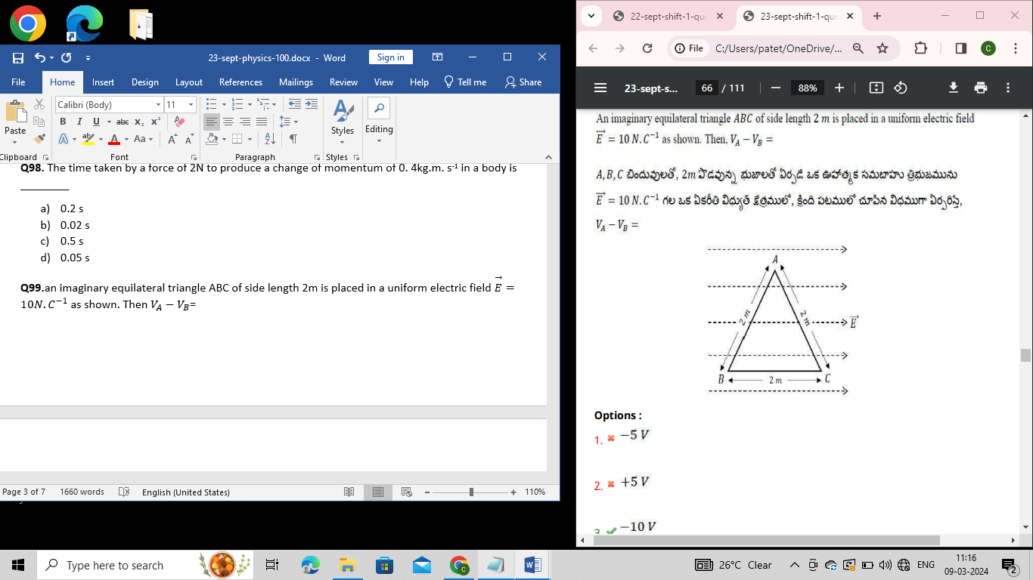
- $-5 V$
- +5 V
- $-10 V$
- $+10 V$
Q100.when will a body of mass 20kg moving at 15 m.s⁻¹, subjected to a retarding force of 100 N, come to rest?
- 3 s
- 6 s
- 1.5 s
- 9 s
Q101. As shown in the figure below, a point charge ‘q’ moves from point ‘P’ to a point ‘S’ traversing a path PQRS in a uniform $\vec{E}$ .The electric field is directed along a direction parallel to x-axis. The coordinates of P, Q, R and S are (a, b,0) (2a,0,0) (a, -b,0) and (0,0,0) respectively. What is the work done by the fields in the process?
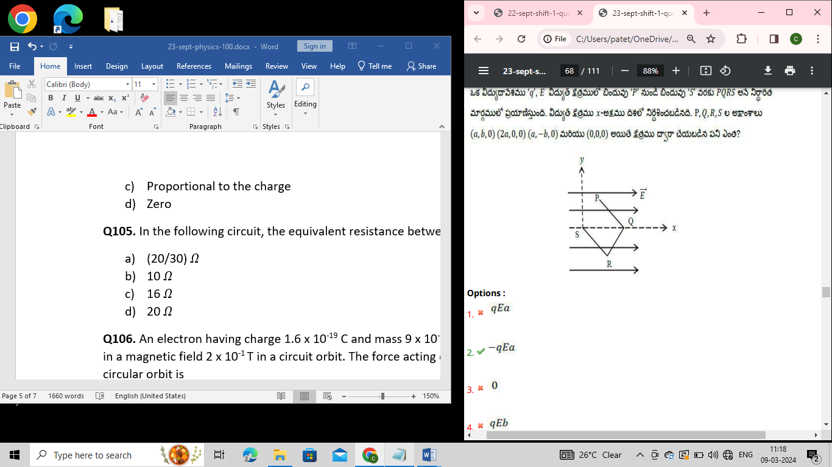
- qEa
- -qEa
- 0
- qEb
Q102. The photoelectric threshold for a certain metal surface is 360 $A^{0}$. If the metal surface is irradiated by a wavelength of 1100 $A^{0}$. The kinetic energy of the emitted photoelectrons is
- 1.1 eV
- 2 eV
- 2.3 eV
- 0
Q103. A closed organ pipe and an open organ pipe of length produced 2 beats/sec when they are set into vibrations together in fundamental mode. the length of open pipe is now halved and that of closed pipe is doubled. The number of beats produced will be
- 7
- 4
- 8
- 2
Q104. The number of electric lines that emerge from a finite charge +q is ________
- Infinite
- Any finite number but not equal to zero
- Proportional to the charge
- Zero
Q105. In the following circuit, the equivalent resistance between A and B is
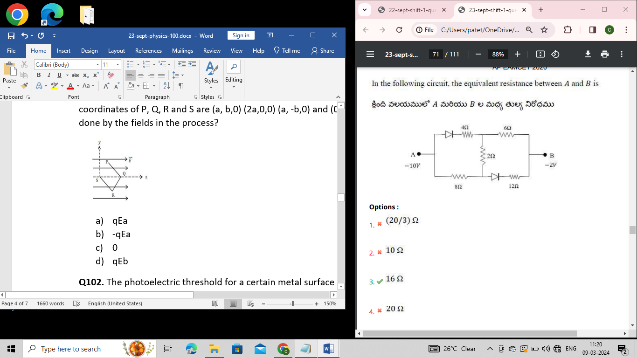
- (20/3)$Ω$
- 10 $Ω$
- 16 $Ω$
- 20 $Ω$
Q106. An electron having charge 1.6 x 10⁻¹⁹ C and mass 9 x 10⁻³¹ kg is moving with 4 x 10⁶ m.s⁻¹ speed in a magnetic field 2 x 10⁻¹ T in a circuit orbit. The force acting on electron and the radius of the circular orbit is ____________
- 12.8 x 10⁻¹³ N,1.1 x 10⁻⁴ m
- 1.28 x 10⁻¹⁴ N,1.1 x 10⁻³ m
- 1.28 x 10⁻¹³ N,1.1 x 10⁻³ m
- 1.28 x 10⁻¹³ N,1.1 x 10⁻⁴ m
Q107. The color code for a resistance of 22 $Ω$ $±$5% is ________
- Brown-brown-black-gold
- Red-red-brown-silver
- Red-red-black-gold
- Red-red-orange-silver
Q108.kinetic energy of rotation of a flywheel of radius 2m. Mass 8kg and angular speed 4 rad. s⁻¹ about an axis perpendicular to its plane and passing through its center is
- 128J
- 196J
- 256J
- 392J
Q109. What is the pressure required to reduce the given volume of water by 1%?
(Bulk modulus(k)=2 x 10⁸ N.m⁻²)
- 2 x 10⁵ N.m⁻²
- 2 x 10⁶ N.m⁻²
- 2 x 10⁷ N.m⁻²
- 2 x 10⁸ N.m⁻²
Q110. A particle executes simple harmonic motion between x=-A and x=+A. If it takes a time T₁ to go from x=0 to x=A/2 and T₂ to go from x=A/2 to x=A. Then
- T₁ < T₂
- T₁ > T₂
- T₁ = T₂
- T₁ =2 T₂
Q111. A mixture of Yellow light of wavelength 580 nm and blue light of wave length 450 nm is incident normally on an air film of thickness 2.9 x 10⁻⁴ mm. The colour of reflected light is
- Red
- Blue
- Violet
- Yellow
Q112.One mole of an ideal diatomic gas undergoes a transition from A to B along a path AB as shown in figure. The change in internal energy of the gas during the transition is
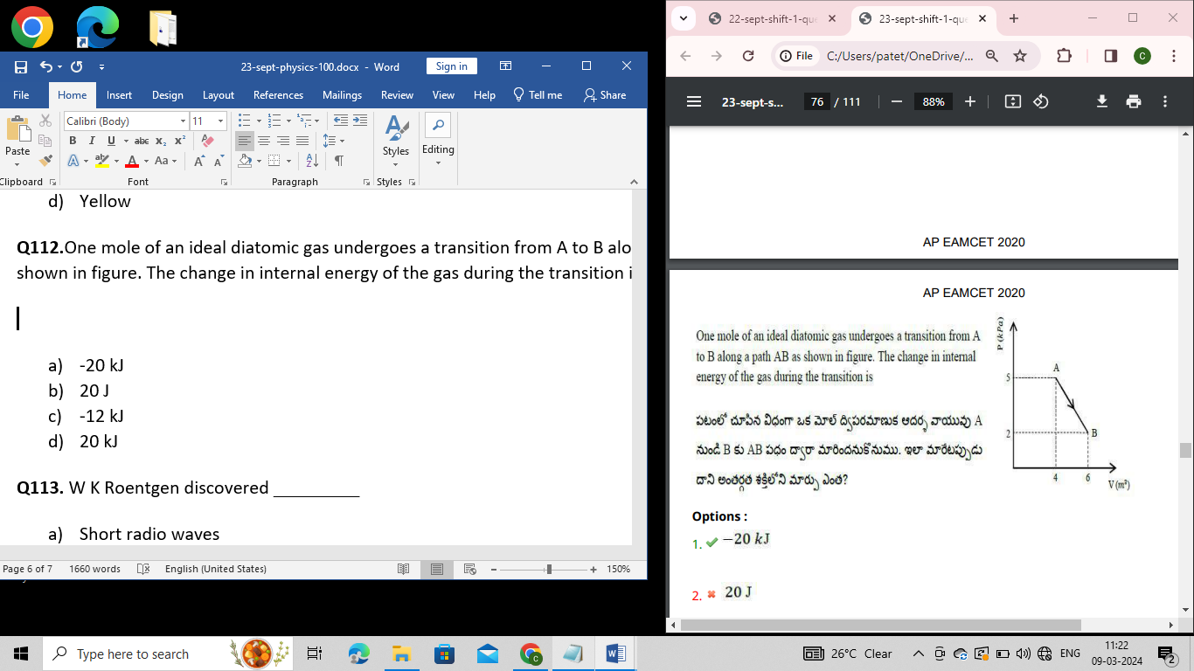
- -20 kJ
- 20 J
- -12 kJ
- 20 kJ
Q113. W K Roentgen discovered _________
- Short radio waves
- X-rays
- Electrons
- Laws of electromagnetic induction
Q114. A source is stationary and the observer is in motion along a line joining the source and the observer. If the frequency heard by the observer is 1% higher than the true frequency, the ratio of velocity of the observer and that of sound in air is:
- 1:100
- 2:100
- 3:100
- 1:10
Q115.Four projectiles are fired with the same velocities at angles 25º, 44º, 55º and 70º with the horizontal. The range of projectile will be largest for the one projectile at angle ___________.
- 25º
- 40º
- 55º
- 70º
Q116. A train is moving towards north. At one place it runs towards north-east. Here, we observe that:
- The radius of curvature of outer rail will be greater than that of the inner rail
- The radius of curvature of inner rail will be greater than that of the outer rail
- The radius of curvature of the outer and inner rails will be the same
- The radius of curvature of inner rail will infinite
Q117. Minimum excitation potential if Bohr’s first orbit of Hydrogen atom is _____
- 3.6 V
- 10.2 V
- 13.6 V
- 3.4 V
Q118. A system goes from A to B via two processes I and II as shown in the figure. If $∆$U₁ and $∆$U₂ are the changes in internal energies in the processes I and II respectively, then
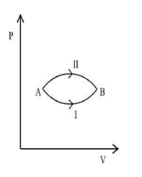
- $∆$U₁=$∆$U₂
- $∆$U₁>$∆$U₂
- $∆$U₁<$∆$U₂
- $∆$U₁$≠∆$U₂
Q119. A uniform solid sphere of radius ‘R’ and radius of gyration ‘K’ above an axis passing through the centre of mass, is rolling without slipping. Then the fraction of total energy associated with its rotation will be_____________
- $\frac{K^{2}+R^{2}}{K^{2}}$
- $\frac{K^{2}}{R^{2}}$
- $\frac{K^{2}}{K^{2}+R^{2}}$
- $\frac{R^{2}}{K^{2}+R^{2}}$
Q120. two thin circular discs A and B of radii 2cm and 4cm are in a liquid at the same depth. T_{A} is the thrust on A and T_{B} thrust on B. Then T_{A}:T_{B}=
- 2:1
- 1:2
- 4:1
- 1:4
Q121. For the reaction, 2H_{2(g)}+O_{2(g)}$2H$₂O_{(g)}. At 300 K, $ΔG and ΔH$of water are -228.4 kj.mol⁻¹ and
-241.60 kj.mol⁻¹ respectively. Then, calculate the value of change in entropy for the given reaction.
- +88 J
- +44 J
- -88 J
- -44 J
Q122. Which of the following represents the structure of inorganic benzene?

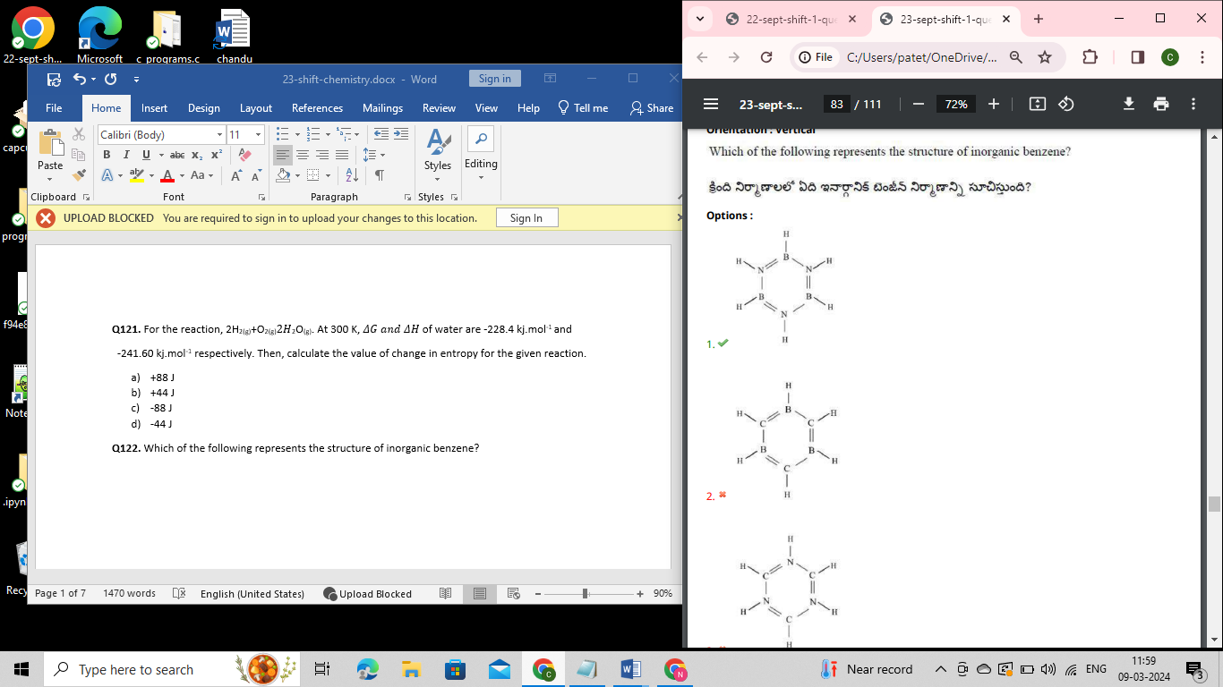

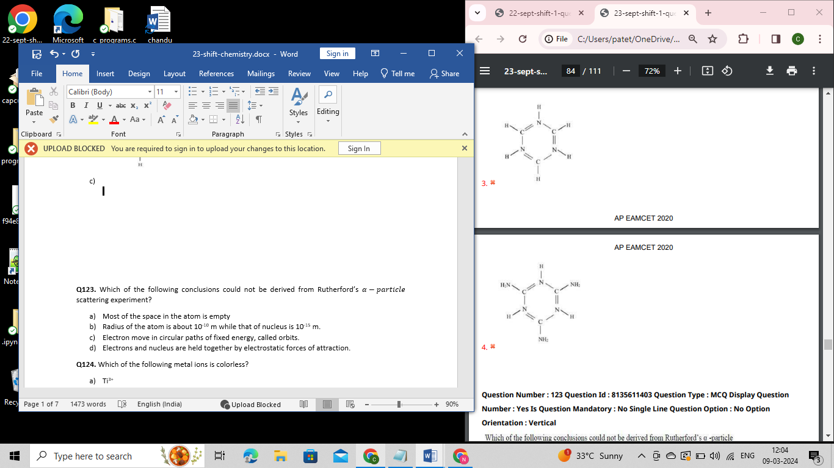

Q123. Which of the following conclusions could not be derived from Rutherford’s $α-particle$ scattering experiment?
- Most of the space in the atom is empty
- Radius of the atom is about 10⁻¹⁰ m while that of nucleus is 10⁻¹⁵ m.
- Electron move in circular paths of fixed energy, called orbits.
- Electrons and nucleus are held together by electrostatic forces of attraction.
Q124. Which of the following metal ions is colorless?
- Ti³⁺
- Sc³⁺
- V⁴⁺
- Cr⁴⁺
Q125. Which of the following arrangement is correct regarding the three types of radii of an atom?
- Metallic radius < Covalent radius <Vander wall’s radius
- Covalent radius < Metallic radius < Vander wall’s radius
- Vander wall’s radius < Metallic radius <Covalent radius
- Metallic radius < Covalent radius < Vander wall’s radius
Q126. Which of the following statement is not true for hydrogen?
- It exists as a diatomic molecule
- It has one electron in the outer most shell
- It can lose an electron to form a cation which can freely exist
- It cannot form ionic compounds
- 1
- 2
- 3
- 4
Q127. When an iron rod is subjected towards an atmosphere having very high content of moisture, which of the process is predominant?
- Chemisorption
- Physisorption
- Sorption
- Luminescence
Q128. The correct statement among the following regarding defects in solids is
- Frenkel defect is favored by small difference in the sizes of cation and anion
- Frenkel defect is a metal excess defect
- Trapping of electron in the lattice leads to formation of F-CENTRE
- Schottky defect has no effect on the physics property of solids

- 1
- 2
- 3
- 4
Q129. Which of the following metal is used as a catalyst in Habe’s process of ammonia synthesis?
- Cobalt
- Copper
- Zinc
- Iron
Q130. Find ‘A’ in the reaction “R ‒OH +A $→$ Schiff’s Base”
- Aldehyde
- Acid
- Alcohol
- Grignard’s Reagent
Q131. Match the following elements, given as hints to their first, second ionization enthalpies and electron gain enthalpies.
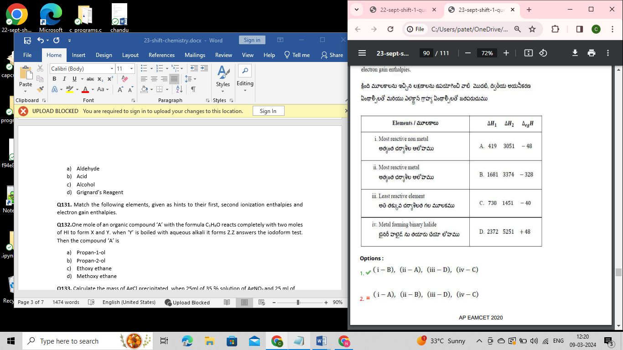
- (i-B), (ii-A), (iii-D), (iv-C)
- (i-A), (ii-B), (iii-D), (iv-C)
- (i-B), (ii-A), (iii-C), (iv-D)
- (i-B), (ii-D), (iii-A), (iv-C)
Q132.One mole of an organic compound ‘A’ with the formula C₃H₈O reacts completely with two moles of HI to form X and Y. when ‘Y’ is boiled with aqueous alkali it forms Z.Z answers the iodoform test. Then the compound ‘A’ is
- Propan-1-ol
- Propan-2-ol
- Ethoxy ethane
- Methoxy ethane
Q133. Calculate the mass of AgCl precipitated, when 25ml of 35 $\%$ solution of AgNO₃ and 25 ml of 11.6 $\%$ solution of NaCl are mixed is ______________
- 7 g
- 17 g
- 20 g
- 15 g
Q134. The pressure exerted by a mixture of 3.2 g of methane and 4.4 g of CO₂ contained in a 9 dm³ flask at 27 ºC is _______
- 1.62 atm
- 8.00 atm
- 0.82 atm
- 3.10 atm
Q135. The increasing order of acidic strength among the following compounds
- Benzoic acid
- 4-Nitrobenzoic acid
- 3,4-Dinitrobenzoic acid
- 4-Methoxybenzoic acid

- I < II < III < IV
- I < IV < II < III
- IV < I < II < III
- IV < I < III < II
Q136. O₃ +2Kl_{(aq)}$→$ ?
- IO₃
- Cl₃
- I₂
- HI
Q137. During electro-osmosis of Fe(OH)₃ sol, which of the following occurs?
- Sol particle move towards anode
- Sol particle move towards cathode
- The dispersion medium moves towards anode
- The dispersion medium moves towards cathode
Q138. The geometry of SF₆ molecule is _______________
- Tetrahedral
- Planar
- Octahedral
- Trigonal bipyramidal
Q139. Which among the following is a bactericidal antibiotic?
- Penicillin
- Erythromycin
- Tetracycline
- Chloramphenicol
Q140. The rate constant is same for 3 reactions of order I, II and III respectively, the unit of concentration being in moles/liter. If the concentration of reactant is unity, rates of reaction R₁, R₂, R₃ will be ___________
- R₁ = R₂ = R₃
- R₁ < R₂ < R₃
- R₁ > R₂ > R₃
- R₁ = R₂ $≠$ R₃
Q141. When soap is dissolved in hard water, it’s cleaning ability comes down. This is due to the formation of:
- (C₁₇H₃₅COO)₂Sn
- (C₁₇H₃₅COO)₂Ca
- C₁₇H₃₅COOLi
- C₁₇H₃₅COOH
Q142. Find the non-semiconductor element among the following.
- Ge
- Pb
- Si
- As
Q143. 10g of a gas STP occupies a volume of 2L. At what temperature will the volume be doubled, if pressure & amount of gas remain constant
- 273 K
- 546 K
- -273 K
- 546 ºC
Q144. Increasing order of boiling points in the following compounds is:
- CH₃COOH
- CH₃CH₂CHO
- CH₃CH₂CH₂OH
- CH₃COCH₃

- (ii) < (iv) < (iii) < (i)
- (ii) < (iv) > (iii) < (i)
- (iv) < (ii) > (i) < (iii)
- (iv) < (iii) > (ii) < (i)
Q145. Predict the correct order of rate of diffraction of the following molecules.
- SO₂ > SO₃ > PCl₃ > CO₂
- PCl₃ > SO₃ > SO₂ > CO₂
- CO₂ > SO₂ > SO₃ > PCl₃
- CO₂ > SO₂ > PCl₃ > SO₃
Q146. For a first order reaction A₅ $→$5B₂, the concentrations vs time plot is as shown. The half-life of the reaction is
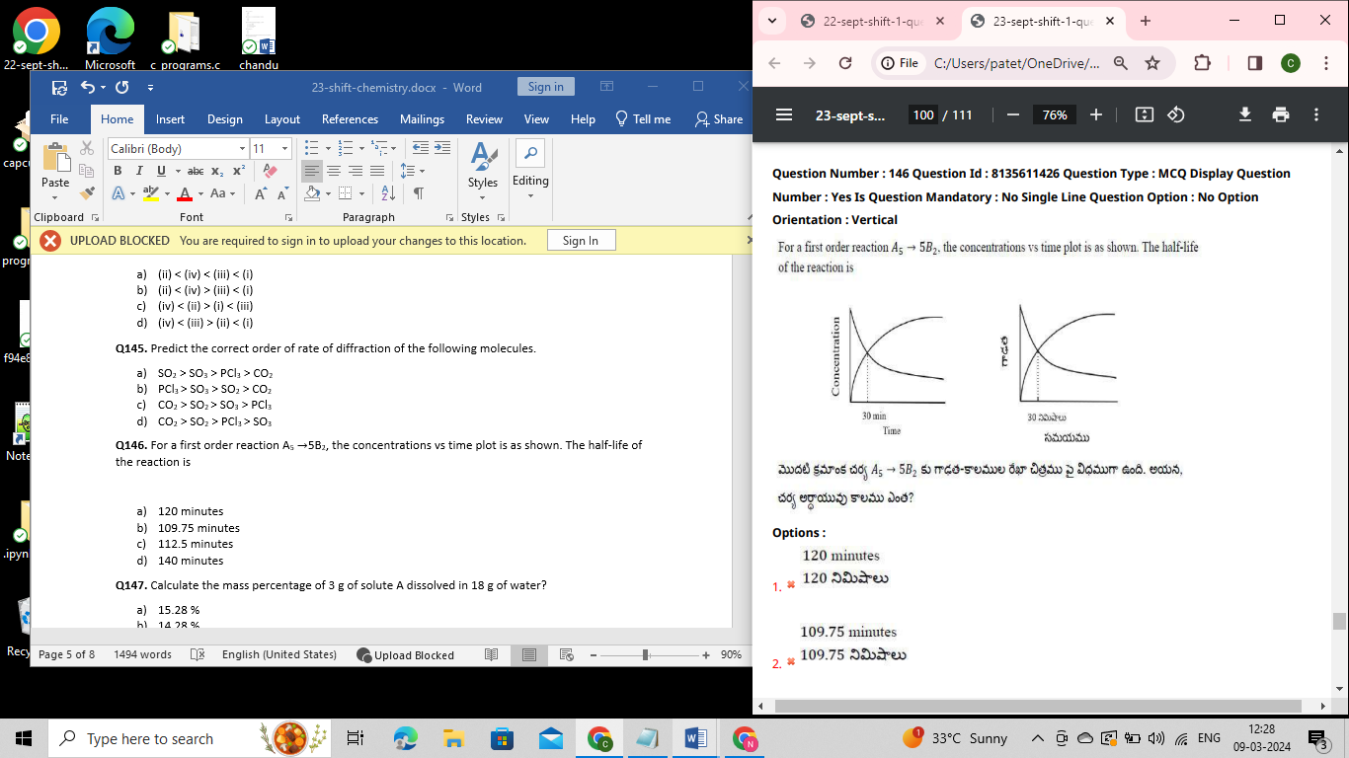

- 120 minutes
- 109.75 minutes
- 112.5 minutes
- 140 minutes
Q147. Calculate the mass percentage of 3 g of solute A dissolved in 18 g of water?
- 15.28 %
- 14.28 %
- 16.28 %
- 17.28 %
Q148. Which of the following statement is true?
- 200ml of 0.2M NaOH has same number of moles of solute as 1000ml of 1M NaOH
- 200ml of 1M NaOH has same number of moles as 1000ml of 0.2M NaOH
- 100ml of 0.2 M NaOH has same number of moles as 1000ml of 1M NaOH
- 2000ml of 0.2M NaOH has same number of moles as 1000ml of 1M NaOH

- 1
- 2
- 3
- 4
Q149. Which of the following metals cannot be obtained by auto-reduction of their compounds?
- Lead
- Mercury
- Titanium
- Copper
Q150. Which of the following is called “Lunar Caustic”?
- NaOH
- AgCl
- AgOH
- AgNO₃
Q151. Which of the following statements is true?
- Tertiary amines react with acid chlorides
- N-Ethyl benzene sulphonamide is soluble in alkali
- N, N-Diethyl benzene sulphonamide is soluble in alkali
- Tertiary amines react with Hindberg’s reagent

- 1
- 2
- 3
- 4
Q152. The total number of $σ$and π bonds present in the following compounds respectively are
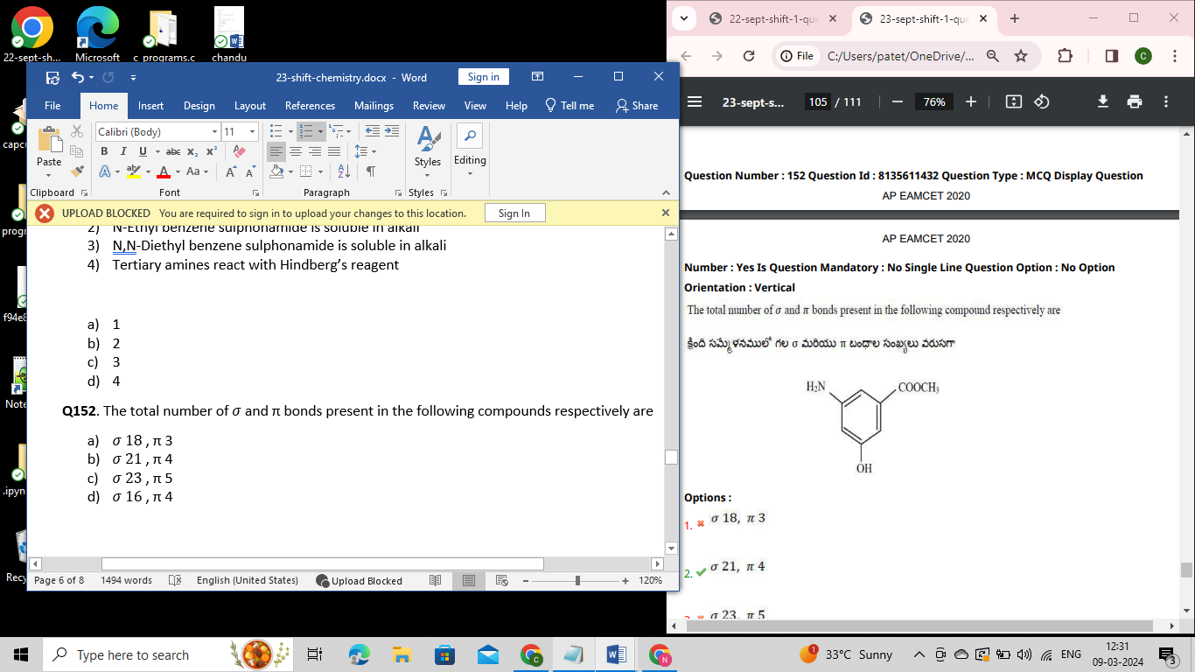
- $σ 18$, π 3
- $σ 21$, π 4
- $σ 23$, π 5
- $σ 16$, π 4
Q153. Which among the following is a correct statement based in Heisenberg’s uncertainty principle?
- It is impossible to determine exact position and exact momentum of an electron simultaneously
- It is applicable to even macroscopic objects
- It is possible to determine the exact position and momentum of an electron simultaneously
- It is impossible to determine the exact position and momentum of macroscopic object simultaneously

- 1
- 2
- 3
- 4
Q154. The product Q and R in the following reactions respectively are
$$H_{2}+CH_{3}C≡CH\underset{→}{Lindlar^{'}s catalyst } \underset{Zn +H_{2}O}{P\underset{→}{ O_{3} } Q+R}$$
- Ethanol, Methanic Acid
- Ethanoic acid, Methanol
- Ethanal, Methanal
- Ethanoic acid, Methanoic acid
Q155. The fraction of voids occupied in inverse spinel compounds are __________
- 1/8th of tetrahedral voids and 1/2 of octahedral voids
- 1/2 of tetrahedral voids and 1/8th of octahedral voids
- 1/4th of tetrahedral voids and 1/8th of octahedral voids
- 1/8th of tetrahedral voids 1/4th of octahedral voids
Q156. Which among the following oxides is the most basic?
- CO
- Al₂O₃
- Cl₂O₇
- Na₂O
Q157. Total number of hydroxyls(‒OH) groups in saccharic acid are:
- 3
- 2
- 4
- 5
Q158. The formation of molecular orbitals can be described by the linear combination of atomic orbitals. Which one of the following correctly represents the formation of bonding molecular orbital from the atomic orbitals having wave functions $ψ$_{A} and $ψ$_{B}?
- $ψ$_{A} x $ψ$_{B}
- $ψ$_{A} / $ψ$_{B}
- $ψ$_{A} + $ψ$_{B}
- $ψ$_{A} – $ψ$_{B}
Q159. The number of isomers of C₅H₁₂ is:
- 3
- 4
- 5
- 2
Q160. Which of the following does not exist?
- XeO₃
- XeOF₄
- XeF₆
- NeF₂

